EX01- FINDING THE TOTAL NUMBER OF CHARACTERS IN A STRING

AIM:
To design and implement a RAPTOR flowchart to find and display the total numbers of characters in a given string.
FLOWCHART:
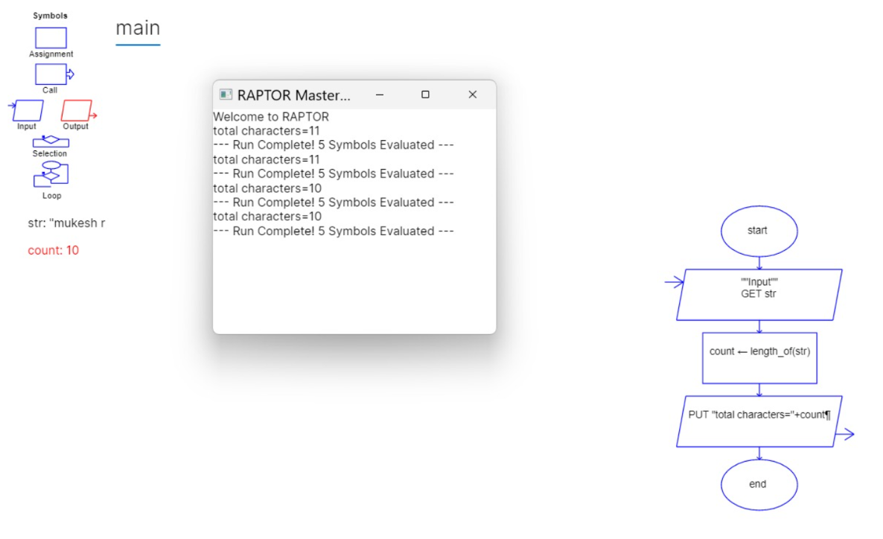
RESULT:
Thus, the RAPTOR flowchart was executed successfully and the total number of characters in the given string was displayed correctly.

EX02- GREATEST OF THREE NUMBERS

AIM:
To design and implement a RAPTOR flowchart to find the largest among three given numbers.
FLOWCHART:
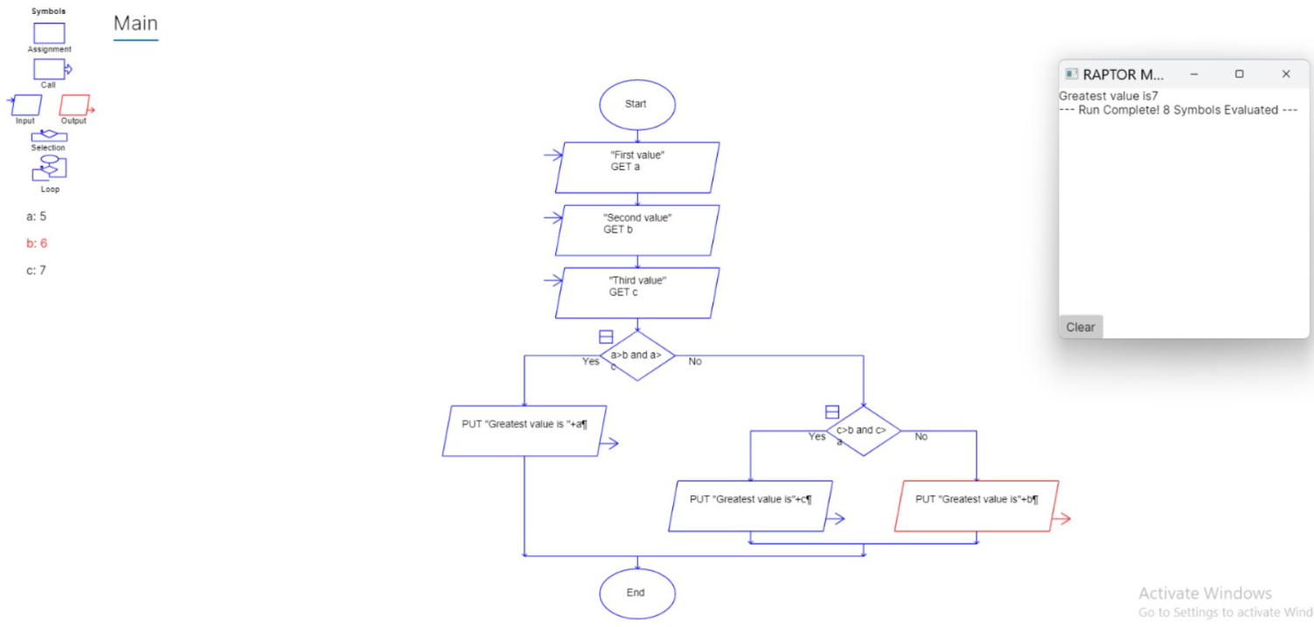
RESULT:
Thus, the RAPTOR flowchart was designed and executed successfully to find the maximum among three given numbers.

EX03- FACTORIAL OF A NUMBER

AIM:
To design and implement a RAPTOR flowchart to find the factorial of a given number.
FLOWCHART:
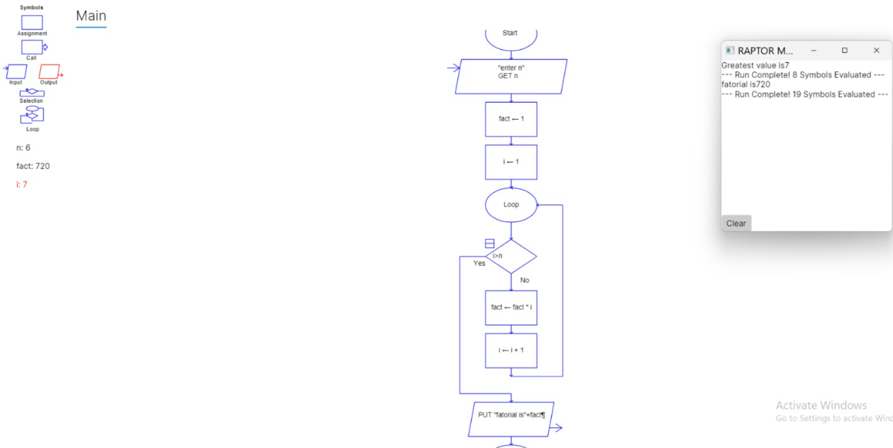

RESULT:
Thus, the RAPTOR flowchart was executed successfully and the factorial of the given number was displayed correctly.

EX04 ARMSTRONG NUMBER

AIM:
To design and implement a RAPTOR flowchart to check whether a given number is an Armstrong number or not.
FLOWCHART:
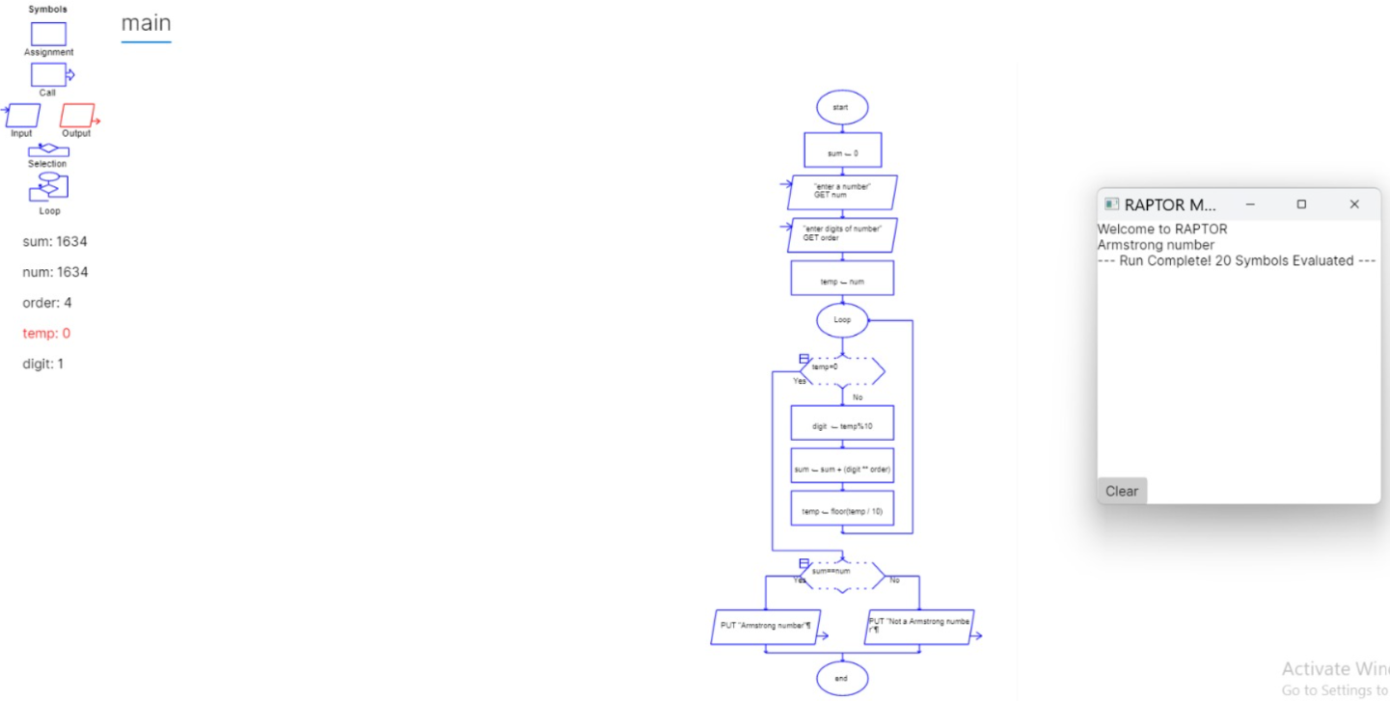

RESULT:
Thus, the RAPTOR flowchart was designed and executed successfully to determine whether the given number is an Armstrong number or not.

EX05- FINDING THE LEXICOGRAPHICALLY SMALLEST STRING BY SWAPPING ANY TWO CHARACTERS USING RAPTOR

AIM:
To design a RAPTOR flowchart to find the lexicographically smallest string after swapping any two characters at most once.
FLOWCHART:
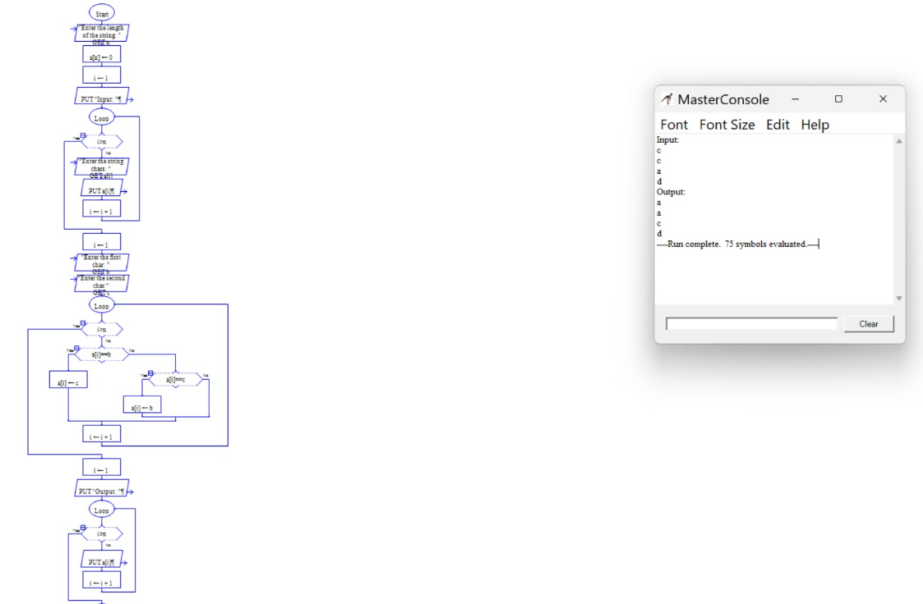
RESULT:
Thus, the RAPTOR flowchart was successfully designed and executed to find the lexicographically smallest string.
EX06- CALCULATION OF CYCLOMATIC COMPLEXITY OF A FLOW GRAPH

AIM:
To design and implement a RAPTOR flowchart to calculate the Cyclomatic Complexity of a flow graph using the given number of edges, nodes, and predicate nodes.
FLOWCHART:
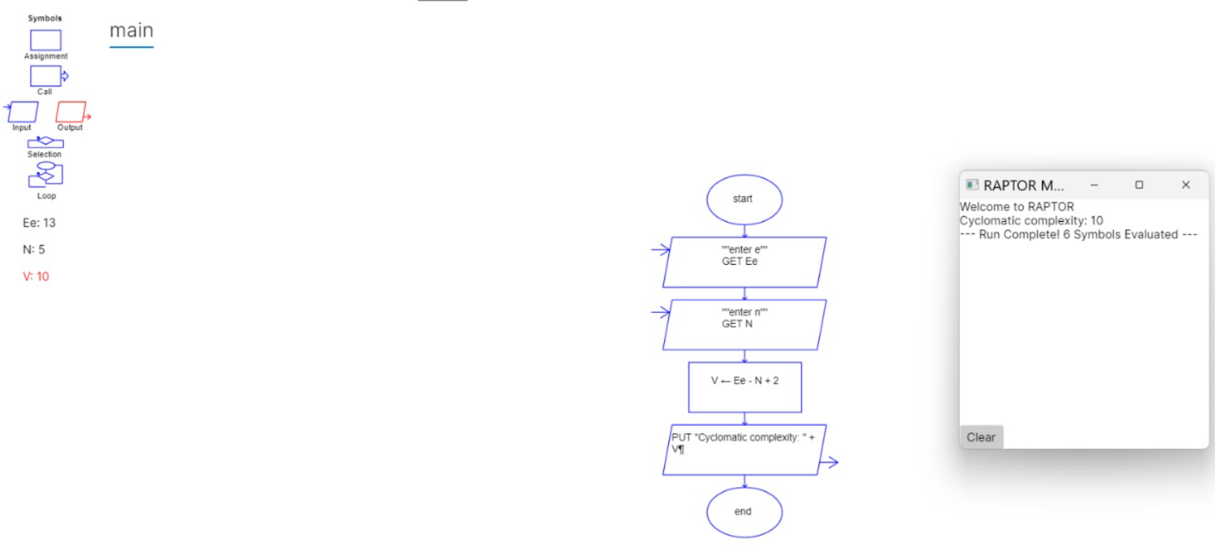
RESULT:
Thus, the RAPTOR flowchart was successfully executed, and the Cyclomatic Complexity was calculated as 10

